Reference 1 : Pianzola, F., et al. (2025). The GOLEM Ontology for Narrative and Fiction. Humanities, 14(10), 193

GOLEM (گُلِم) (which stands for Graphs and Ontologies for Literary Evolution Models) refers to a state-of-the-art computational framework and ontology designed specifically for the structured representation of narrative structures, fictional worlds, characters, relationships, events … It provides strong academic grounding for applying semantic technologies to fictional domains like Harry Potter.
Contribution to our methodology: Our project explicitly converts complex narrative knowledge from the Harry Potter universe into a structured, machine-readable RDF/OWL graph. This paper gives us the academic authority to prove that modeling a fictional story with strict Description Logic rules is highly scientifically valid.

For the structural design of our ontology, we looked at the 2025 paper on the GOLEM ontology. GOLEM is specifically designed to address how fiction and narrative elements should be represented in the Semantic Web.
We used it in the Introduction and Related Work sections to ground our modeling of Harry Potter characters and relationships in current academic research on fiction ontologies and participatory culture.

Specific Usage in Our Ontology Design (Class Hierarchy and Subclasses)
The GOLEM ontology strongly informed our class hierarchy and subclass modeling in Protégé:
- Person as the root class: Following GOLEM’s modular approach to fictional entities, we established Person as the foundational superclass. This provides a cognitively grounded and interoperable upper-level class for all narrative agents, accommodating both canonical and fan-driven interpretations of characters.
- Sibling subclasses under Person (Student, Professor, Wizard, DarkWizard): GOLEM emphasizes the need for flexible, non-hierarchically rigid modeling of fictional characters to support automated reasoning and pluralistic interpretations. We deliberately modeled Student and Wizard as direct siblings (rather than nesting Student under Wizard). This design choice maximizes the expressive power of Description Logic reasoning: the HermiT reasoner can infer that a Student who castsSpell qualifies as a Wizard, mirroring GOLEM’s capacity to handle dynamic character identity and emergent properties across narrative contexts.
- Disjoint classes (e.g., Professor ⊥ Student): This aligns with GOLEM’s commitment to logical consistency while preserving narrative complexity. By enforcing mutual exclusivity, we prevent semantic contradictions (e.g., an individual cannot simultaneously be both a student and a professor), supporting the ontology’s consistency checking.
- Existential restrictions (e.g., Student ⊆ ∃belongsToHouse.House): This mirrors GOLEM’s use of restrictions and properties to capture essential narrative relationships and ensure graph integrity.
Our object properties (belongsToHouse, friendOf (symmetric), castsSpell, enemyOf, teaches/taughtBy (inverse)) and data properties further operationalize GOLEM’s relational and feature-modeling patterns for characters and narrative elements.

We grounded our ontological design in Pianzola et al. (2025)’s GOLEM Ontology for Narrative and Fiction. Their modular framework, which extends CIDOC-CRM and aligns with DOLCE, directly informed our class hierarchy—particularly the modeling of Person as superclass with sibling subclasses (Student, Wizard, Professor)—and the use of existential restrictions and property characteristics to enable automated reasoning on fictional characters.
The design of our Harry Potter domain ontology is grounded in the GOLEM Ontology for Narrative and Fiction (Pianzola et al., 2025), particularly its Character Module. Following GOLEM’s modular and cognitively grounded approach, which extends CIDOC-CRM’s E89 Propositional Object and aligns with DOLCE’s agentive-social-object taxonomy (pp. 13–15), we defined Person as the root superclass encompassing all narrative agents. To maximize the expressive power of automated reasoning, we modeled the key subclasses—Student, Professor, Wizard, and DarkWizard—as direct siblings under Person rather than through strict hierarchical nesting. This sibling structure, inspired by GOLEM’s two-level modeling of character identity (G0_Character-Stoff for abstract concepts and G1_Character for specific instantiations), allows the HermiT reasoner to dynamically infer implicit classifications, such as classifying a Student as a Wizard when the castsSpell property is asserted. Logical consistency is further ensured through formal Description Logic axioms, including the disjointness between Professor and Student classes and the existential restriction Student ⊆ ∃belongsToHouse.House. Object properties such as belongsToHouse (with its inverse hasMember), symmetric friendOf, and inverse properties teaches/taughtBy were implemented to capture essential narrative relationships, while data properties (hasName, hasAge, hasTitle) provide literal attributes. This design choice not only guarantees graph integrity and prevents semantic contradictions but also aligns our ontology with contemporary standards for modeling fictional characters in participatory culture.

Class Hierarchy & Person as Root Class:
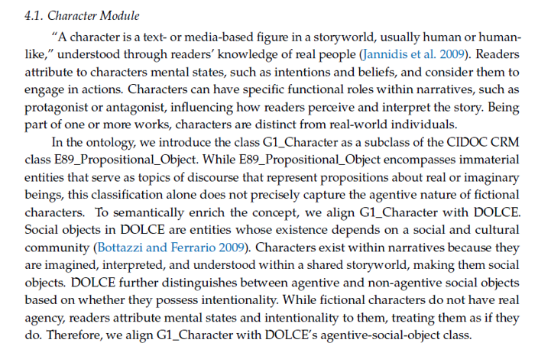

: In the “Class Hierarchy & Properties” and “Conceptual Modeling” slides, we presented Person as the root superclass with Student, Professor, Wizard, and DarkWizard as subclasses. We referenced GOLEM to justify modeling all narrative agents under one upper-level class (Person), directly inspired by G1_Character’s extension of E89 Propositional Object.

Sibling Subclasses & Automated Reasoning:
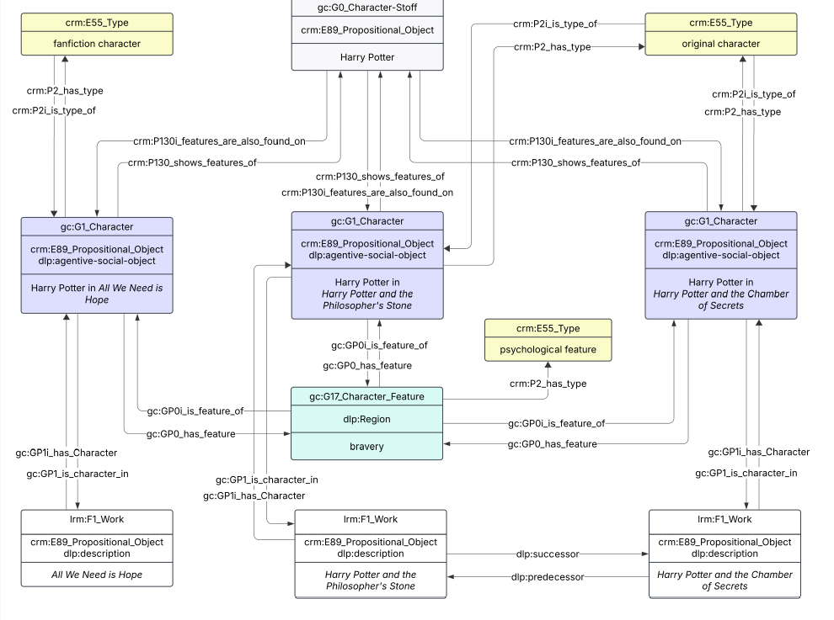
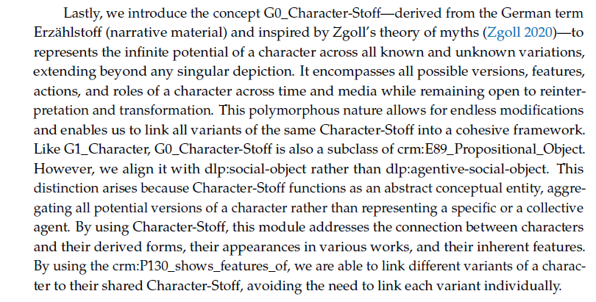
: Student & Wizard Siblings: We modeled these as direct subclasses of Person rather than nesting them. Justification: This design maximizes the power of automated reasoning; the reasoner automatically infers that a Student is a Wizard if they possess the castsSpell property.
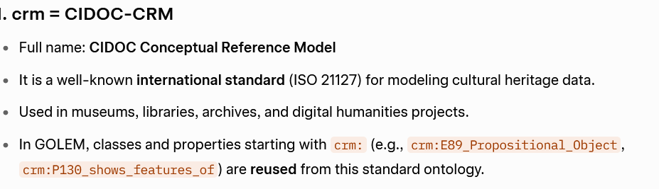
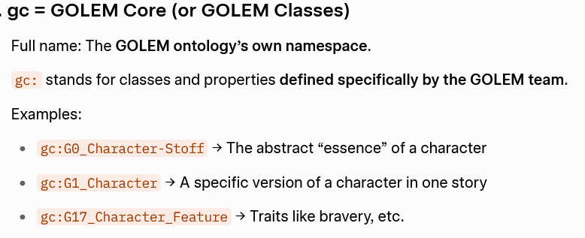
●Scotti, L., et al. (2016). Grounding the Development of Ontologies for Fictional Characters.

This paper provides methodological and philosophical foundations for building ontologies of fictional characters. It surveys existing narrative/fictional ontologies, critically analyzes their modeling strategies, and proposes ways to align them with foundational ontologies.

Character aligned with DOLCE
ontology alignment / harmonization:

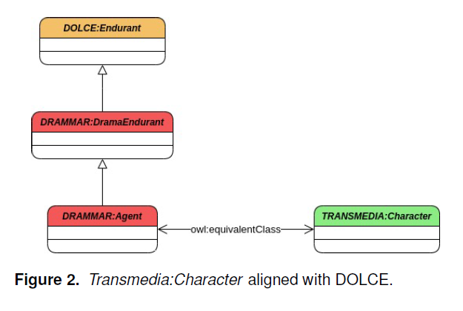
This diagram shows ontology alignment / harmonization.
It illustrates how DRAMMAr:Agent is declared as owl:equivalentClass with TRANSMEDIA:Character, and then both are aligned upward to DOLCE:Endurant.
Focus: Equivalence (≡) and subclass relationships (⊑).

this is the ontology we used in our project:
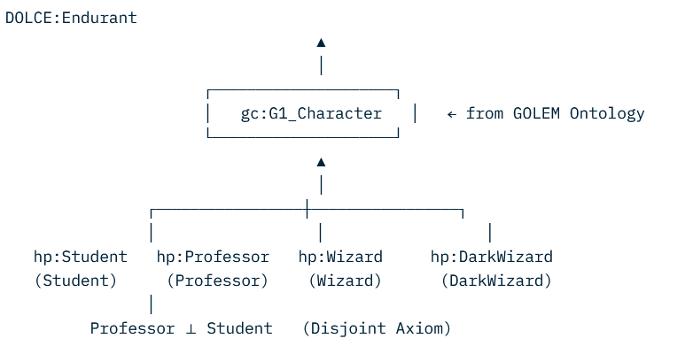

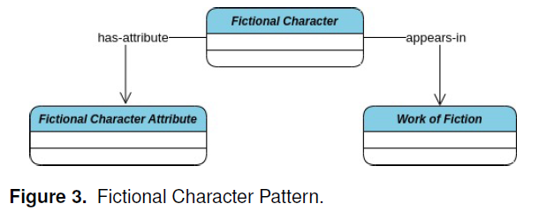
Fictional Character Pattern
- This is a simple high-level pattern showing a central Fictional Character class connected to two other classes via object properties (has-attribute and appears-in).
- Focus: Basic class structure and relationships.
we used in our project:
Character Pattern in Our Harry Potter Ontology
- This is a simple high-level pattern showing a central Person (and its subclasses such as Student and Wizard) as the core class.
- It is connected to other classes via key object properties, including:
  - belongsToHouse → links to the House class
  - castsSpell → links to the Spell class
  - friendOf / enemyOf → links to other Person / Wizard instances
  - teaches / attendsSchool → links to academic and institutional elements

Disjoint Classes & Logical Consistency
Used for: Our Professor ⊥ Student disjoint axiom : ensuring one individual cannot belong to both classes at the same time

Following the methodological guidance of Scotti et al. (2016), who emphasize the importance of explicit ontological commitments and logical consistency when modeling fictional characters (Sections 3 and 5), we introduced the disjointness axiom Professor ⊥ Student. This axiom prevents semantic contradictions by ensuring that no individual can simultaneously belong to both classes, thereby maintaining the integrity and reasoning capabilities of our ontology.

